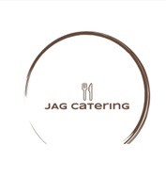
Donaghadee Golf Club
Snack Menu
Sausage & Bacon Bap with a scoop of Chips £4.50
Beef Bourguignon served with Garlic Mash £8
Lasagne, Salad and Garlic Bread £8
Chicken Curry served with Basmati Rice & Poppadum £8.95

Dressed 6oz Steak Burger with Bacon & Cheese £8.50
Chicken Caesar Salad with Croutons, Sundried Tomatoes & Shaved Parmesan £8
Chicken Goujons Tossed in Honey Chilli Sauce on Dressed Leaves with Homecut Chips £8
Crispy Batter Cod, Mushy Peas, Tartar Sauce and Homecut Chips £8

